**ASSIGNMENT – 7**

**ON: JOINS OR DISPLAYING DATA FROM MULTIPLE TABLES**

**Q1. Write a query to display the last name, department number, and department name for all employees.**

|  |  |  |
| --- | --- | --- |
| **LAST_NAME** | **DEPARTMENT_ID** | **DEPARTMENT_NAME** |
| **Whalen** | **10** | **Administration** |
| **Hartstein** | **20** | **Marketing** |
| **Fay** | **20** | **Marketing** |
| **Mourgos** | **50** | **Shipping** |
| **Rajs** | **50** | **Shipping** |
| **Davies** | **50** | **Shipping** |
| **Matos** | **50** | **Shipping** |
| **Vargas** | **50** | **Shipping** |
|  |  |  |
|  |  |  |
| **Higgins** | **110** | **Accounting** |
| **Gietz** | **110** | **Accounting** |

**19 rows selected.**

Ans1.

**Syntax of Oracle Proprietary Joins (8i and prior):**

SELECT e.LAST_NAME, e.DEPARTMENT_ID, d.DEPARTMENT_NAME

FROM EMPLOYEES e, DEPARTMENTS d

WHERE e.DEPARTMENT_ID = d.DEPARTMENT_ID;

**Verification table-**

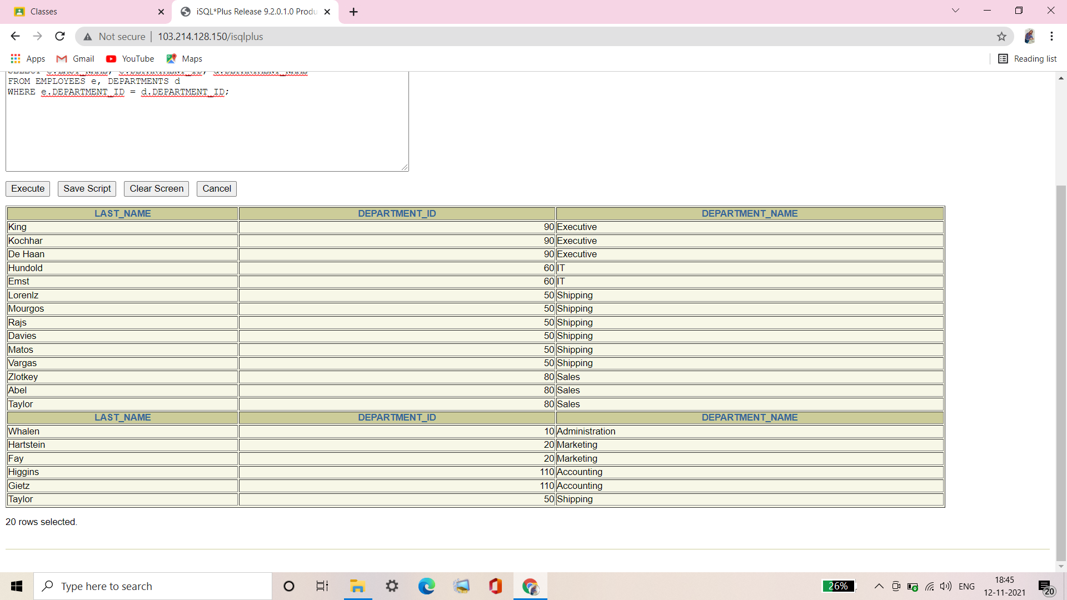

**Syntax of SQL: 1999 Compliant Joins:**

SELECT e.LAST_NAME, e.DEPARTMENT_ID, d.DEPARTMENT_NAME

FROM EMPLOYEES e JOIN DEPARTMENTS d

ON (e.DEPARTMENT_ID = d.DEPARTMENT_ID);

**Verification table-**

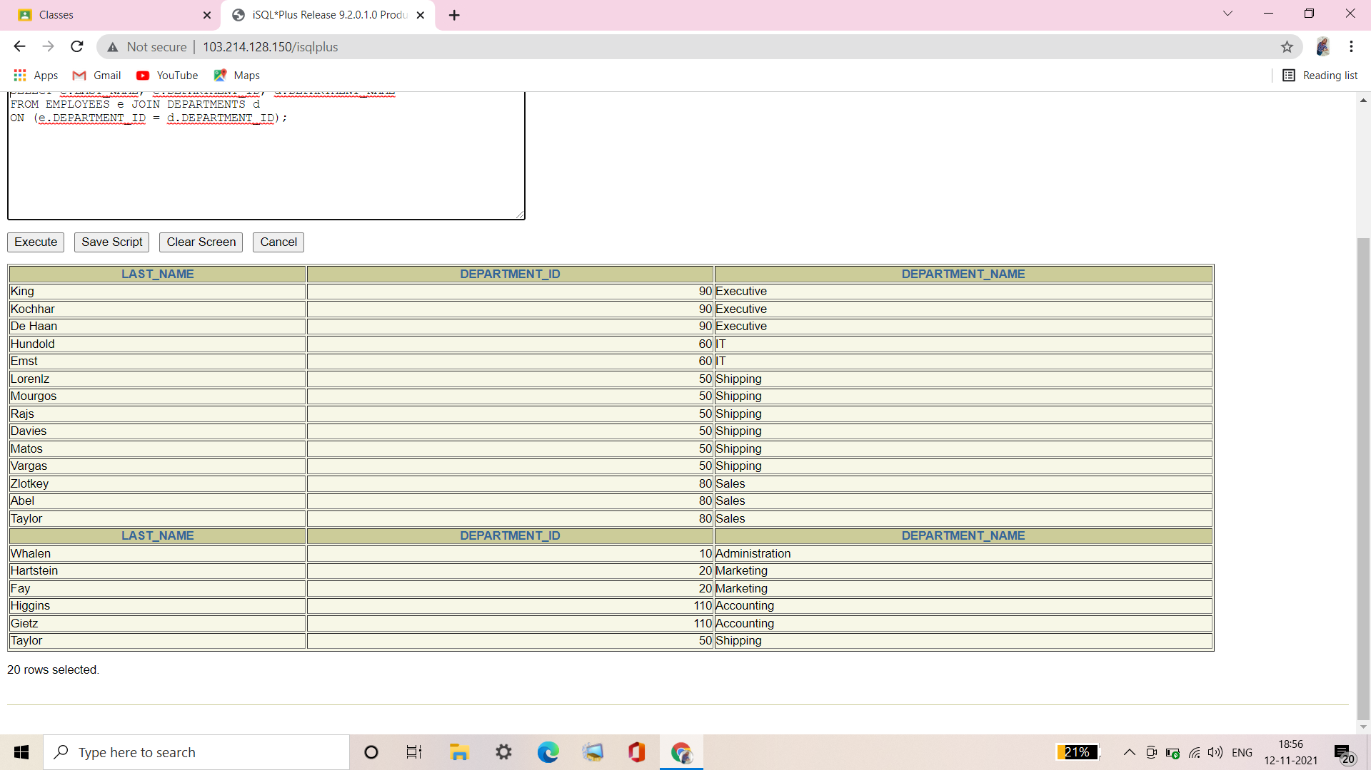

**Q2. Create a unique listing of all jobs that are in department 80. Include the location of department 80 in the output.**

|  |  |
| --- | --- |
| **JOB_ID** | **LOCATION_ID** |
| **SA_MAN** | **2500** |
| **SA_REP** | **2500** |

Ans2.

**Syntax of Oracle Proprietary Joins (8i and prior):**

SELECT DISTINCT JOB_ID, LOCATION_ID

FROM EMPLOYEES e, DEPARTMENTS d

WHERE e.DEPARTMENT_ID = d.DEPARTMENT_ID

AND e.DEPARTMENT_ID = 80;

**Verification table-**

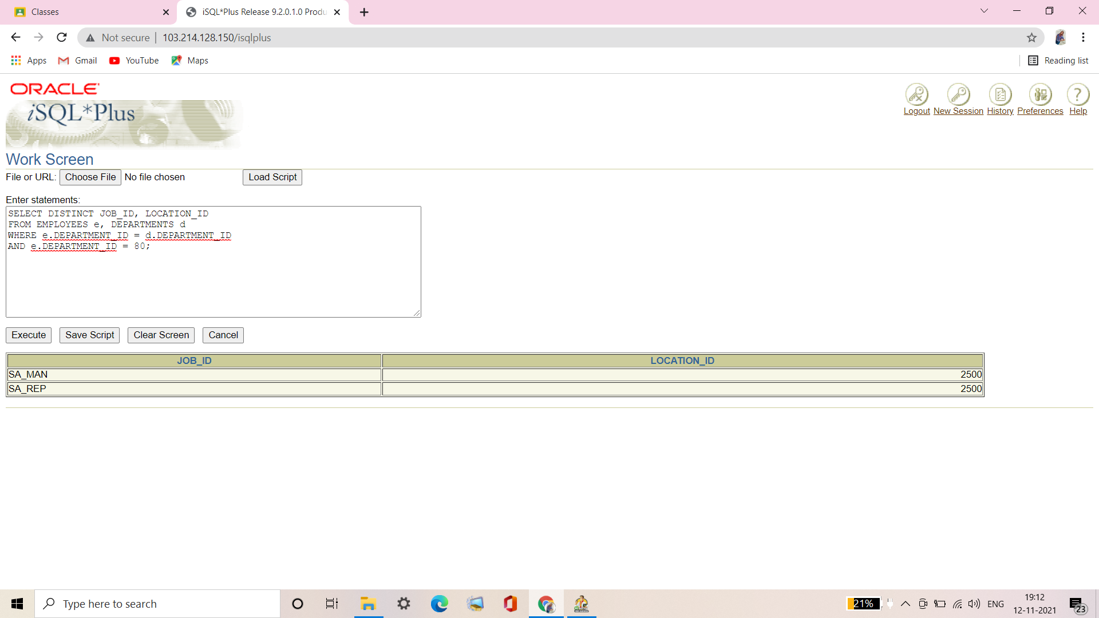

**Syntax of SQL: 1999 Compliant Joins:**

SELECT DISTINCT e.JOB_ID, d.LOCATION_ID

FROM EMPLOYEES e JOIN DEPARTMENTS d

ON (e.DEPARTMENT_ID = d.DEPARTMENT_ID)

WHERE e.DEPARTMENT_ID = 80;

**Verification table-**

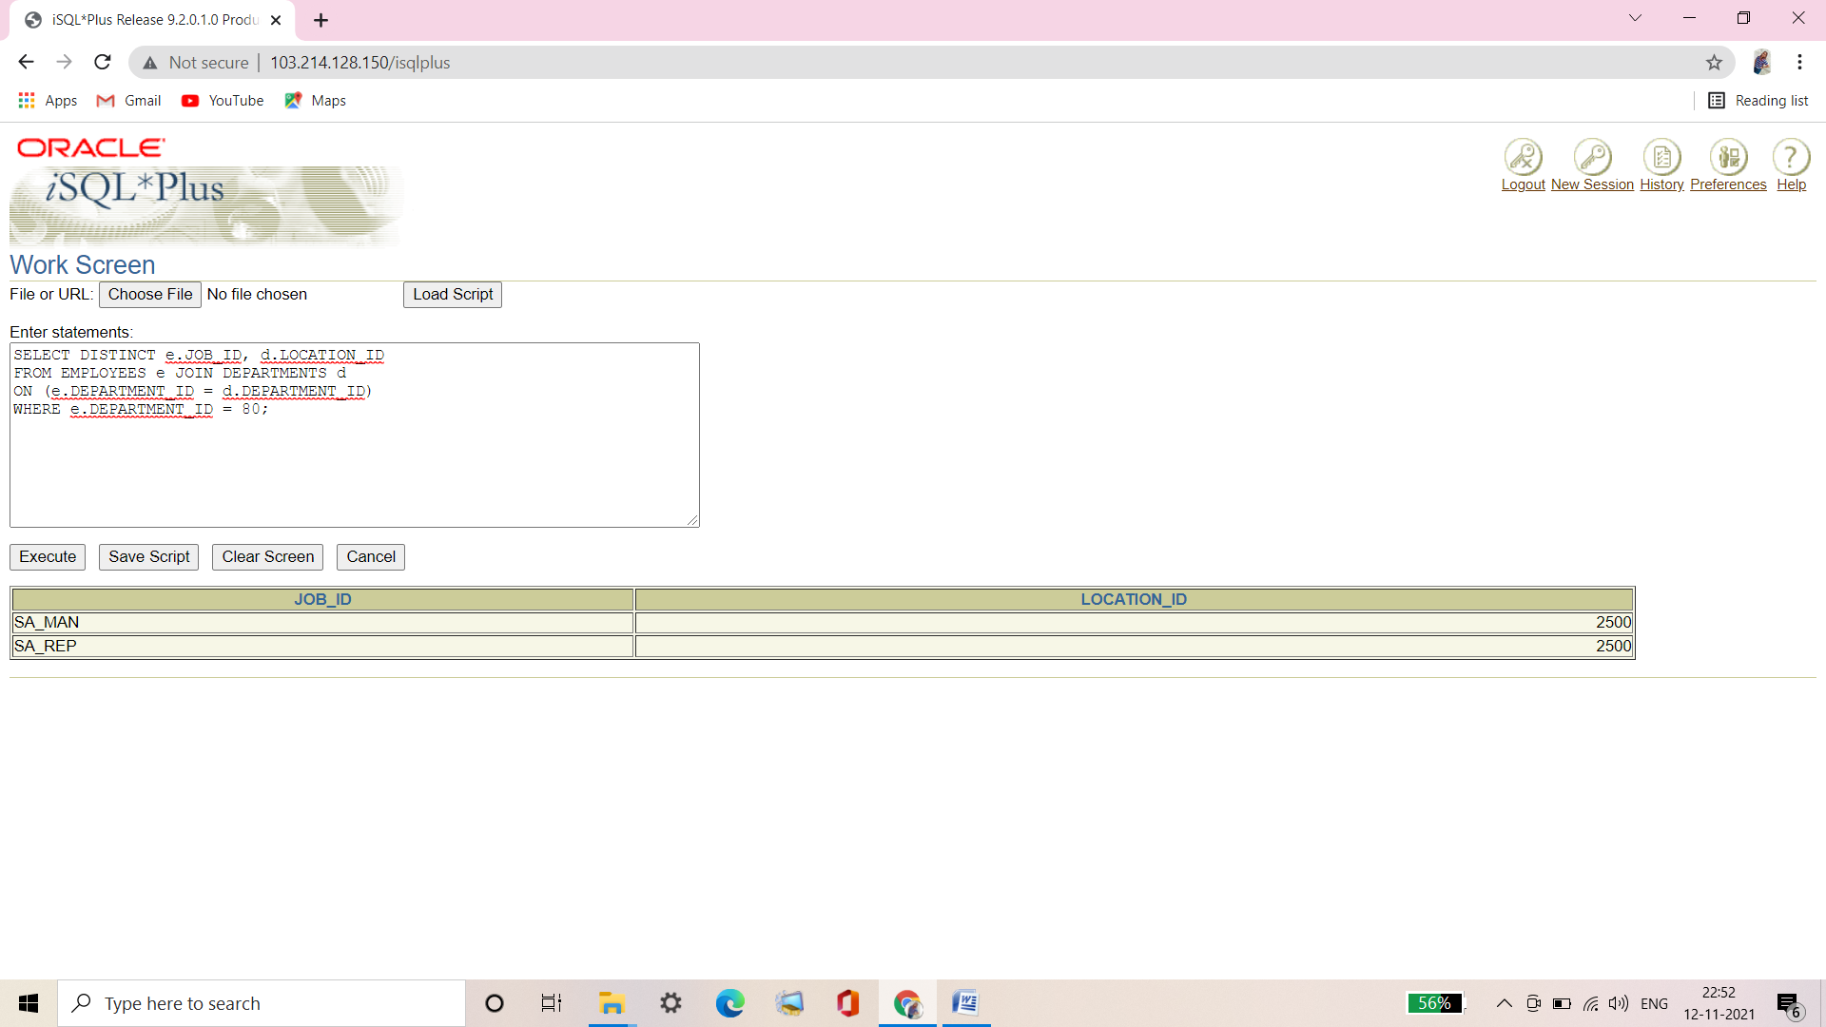

**Q3. Write a query to display the employee last name, department name, location ID, and city of all employees who earn a commission.**

|  |  |  |  |
| --- | --- | --- | --- |
| **LAST_NAME** | **DEPARTMENT_NAME** | **LOCATION_ID** | **CITY** |
| **Zlotkey** | **Sales** | **2500** | **Oxford** |
| **Abel** | **Sales** | **2500** | **Oxford** |
| **Taylor** | **Sales** | **2500** | **Oxford** |

Ans3.

**Syntax of Oracle Proprietary Joins (8i and prior):**

SELECT e.LAST_NAME, d.DEPARTMENT_NAME, d.LOCATION_ID, l.CITY

FROM EMPLOYEES e, DEPARTMENTS d, LOCATIONS l

WHERE e.DEPARTMENT_ID =d.DEPARTMENT_ID

AND d.LOCATION_ID = l.LOCATION_ID

AND e.COMMISSION_PCT IS NOT NULL;

**Verification table-**

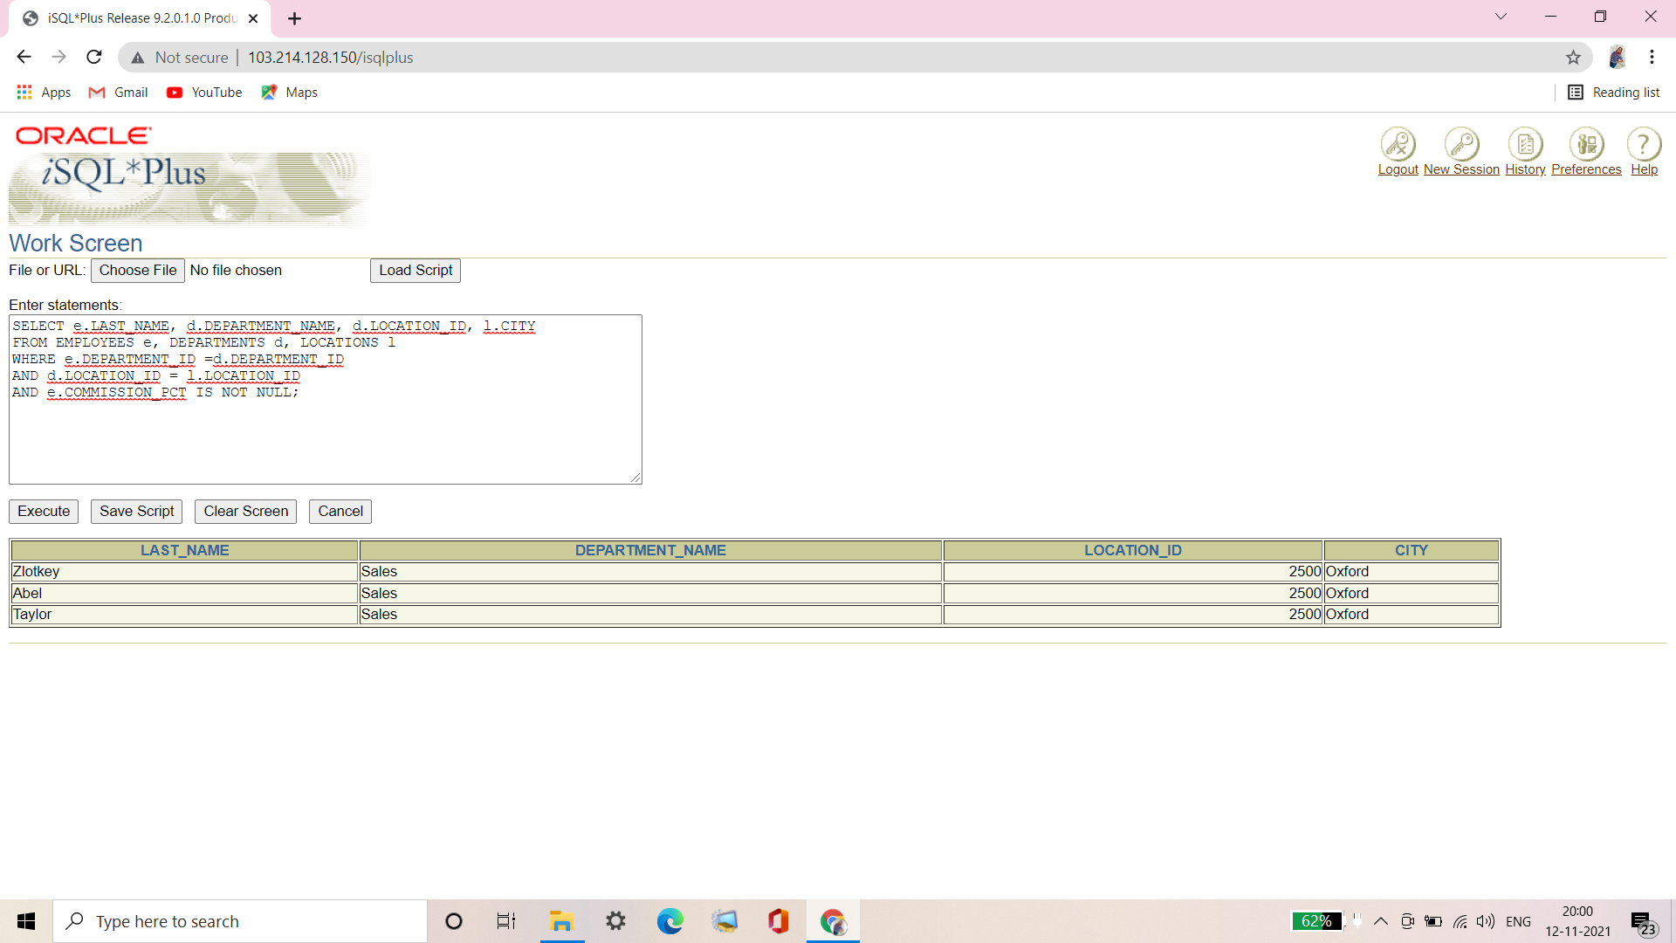

**Syntax of SQL: 1999 Compliant Joins:**

SELECT LAST_NAME, DEPARTMENT_NAME, LOCATION_ID, CITY

FROM EMPLOYEES e

JOIN DEPARTMENTS d

ON (d.DEPARTMENT_ID = e.DEPARTMENT_ID)

JOIN LOCATIONS l

ON (d.LOCATION_ID = l.LOCATION_ID)

AND e.COMMISSION_PCT IS NOT NULL;

**Verification table-**

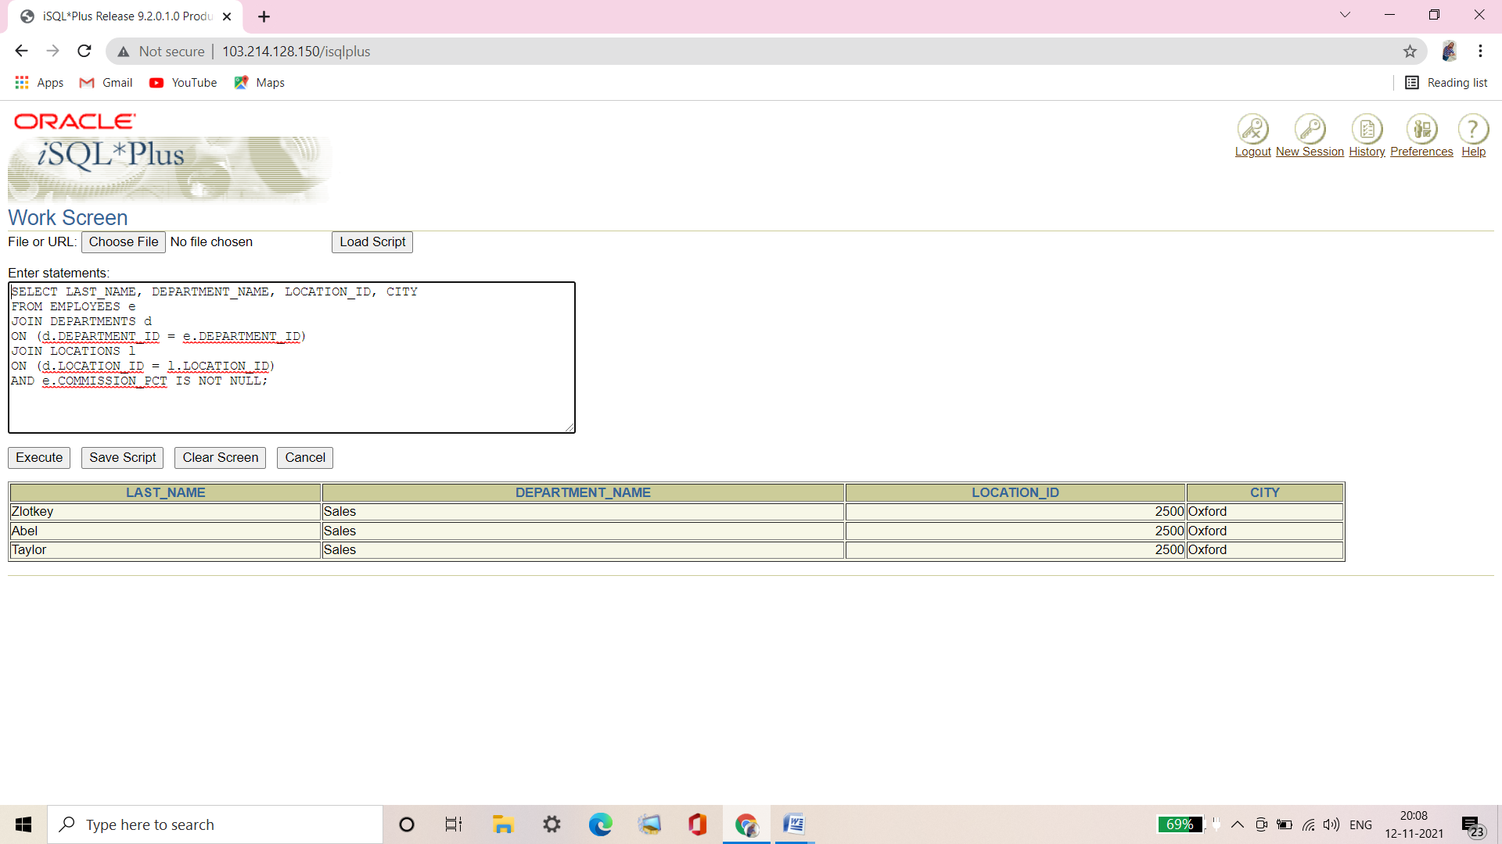

**Q4. Display the employee last name and department name for all employees who have an a (lowercase) in their last names. Place your SQL statement in a text file named lab7_4.sql.**

|  |  |
| --- | --- |
| **LAST_NAME** | **DEPARTMENT_NAME** |
| **Whalen** | **Administration** |
| **Hartstein** | **Marketing** |
| **Fay** | **Marketing** |
| **Rajs** | **Shipping** |
| **Davies** | **Shipping** |
| **Matos** | **Shipping** |
| **Vargas** | **Shipping** |
| **Taylor** | **Sales** |
| **Kochhar** | **Executive** |
| **De Haan** | **Executive** |

**10 rows selected.**

Ans4.

**Syntax of Oracle Proprietary Joins (8i and prior):**

SELECT LAST_NAME, DEPARTMENT_NAME

FROM EMPLOYEES e, DEPARTMENTS d

WHERE e.DEPARTMENT_ID = d.DEPARTMENT_ID

AND LAST_NAME LIKE '%a%';

**Verification table-**

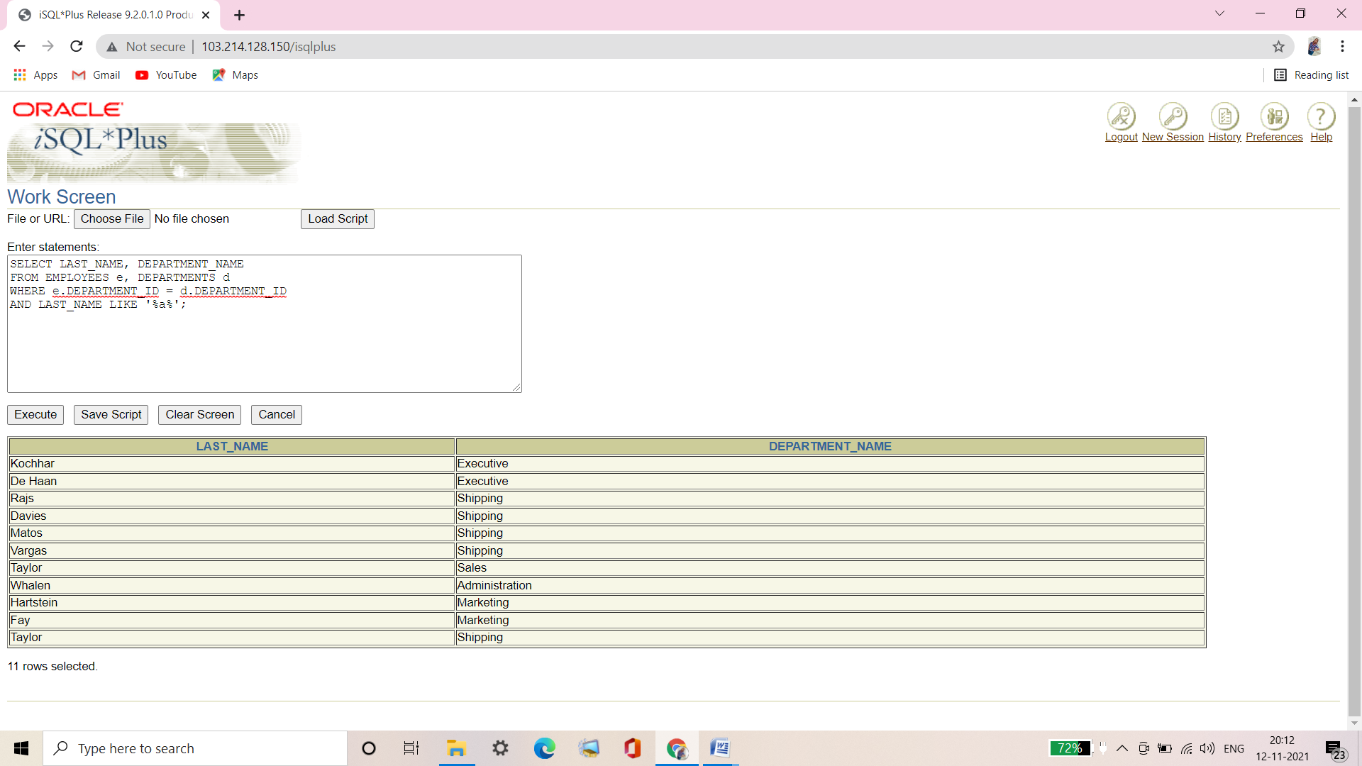

**Syntax of SQL: 1999 Compliant Joins:**

SELECT e.LAST_NAME, d.DEPARTMENT_NAME

FROM EMPLOYEES e JOIN DEPARTMENTS d

ON (e.DEPARTMENT_ID = d.DEPARTMENT_ID)

AND LAST_NAME LIKE '%a%';

**Verification table-**

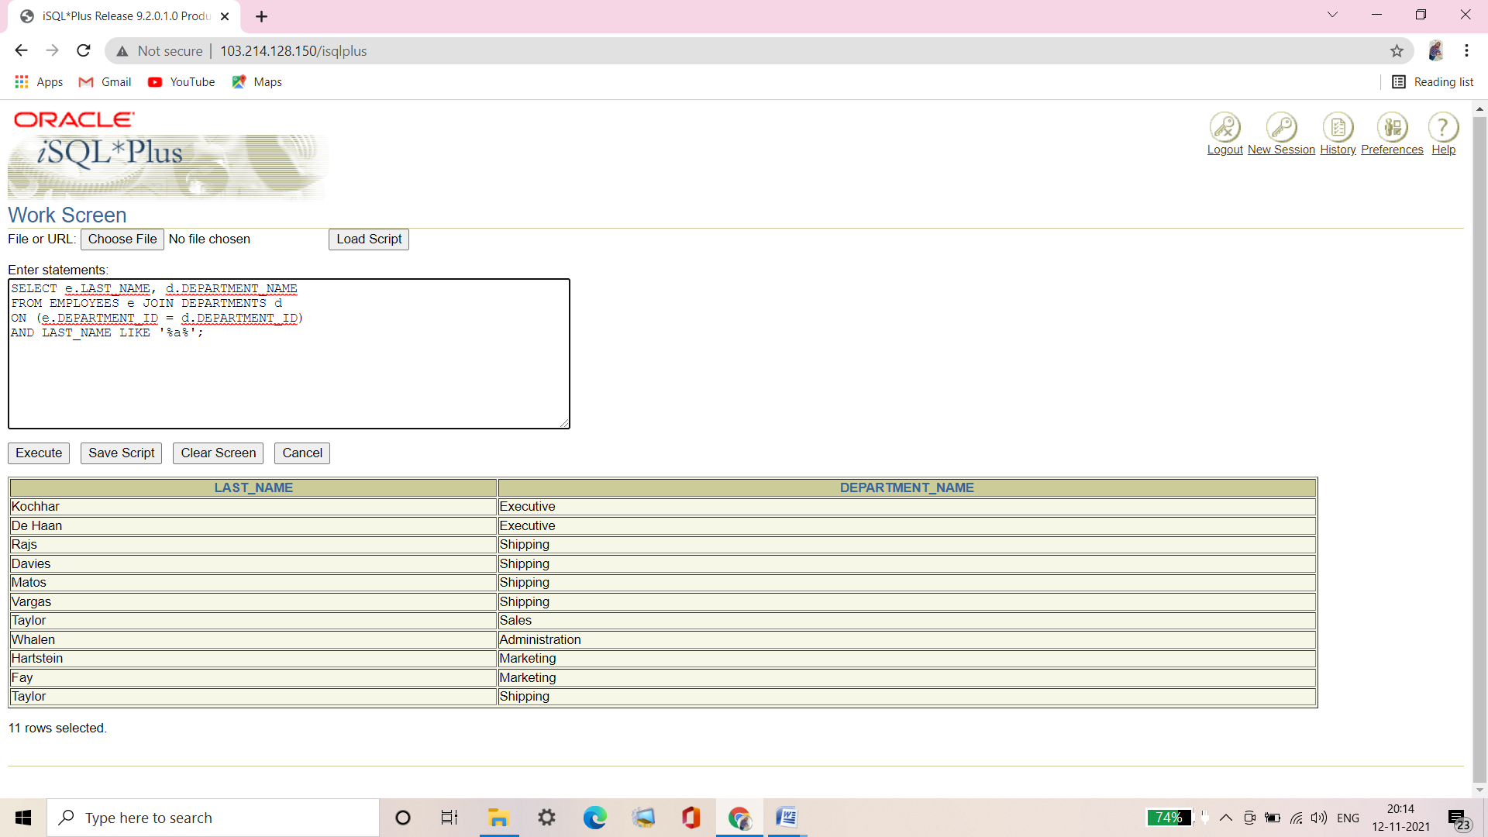

**Q5. Write a query to display the last name, job, department number, and department name for all employees who work in Toronto.**

|  |  |  |  |
| --- | --- | --- | --- |
| **LAST_NAME** | **JOB_ID** | **DEPARTMENT_ID** | **DEPARTMENT_NAME** |
| **Hartstein** | **MK_MAN** | **20** | **Marketing** |
| **Fay** | **MK_REP** | **20** | **Marketing** |

Ans5.

**Syntax of Oracle Proprietary Joins (8i and prior):**

SELECT e.LAST_NAME, e.JOB_ID, e.DEPARTMENT_ID, d.DEPARTMENT_NAME

FROM EMPLOYEES e, DEPARTMENTS d, LOCATIONS l

WHERE e.DEPARTMENT_ID = d.DEPARTMENT_ID

AND d.LOCATION_ID = l.LOCATION_ID

AND l.CITY = 'Toronto';

**Verification table-**

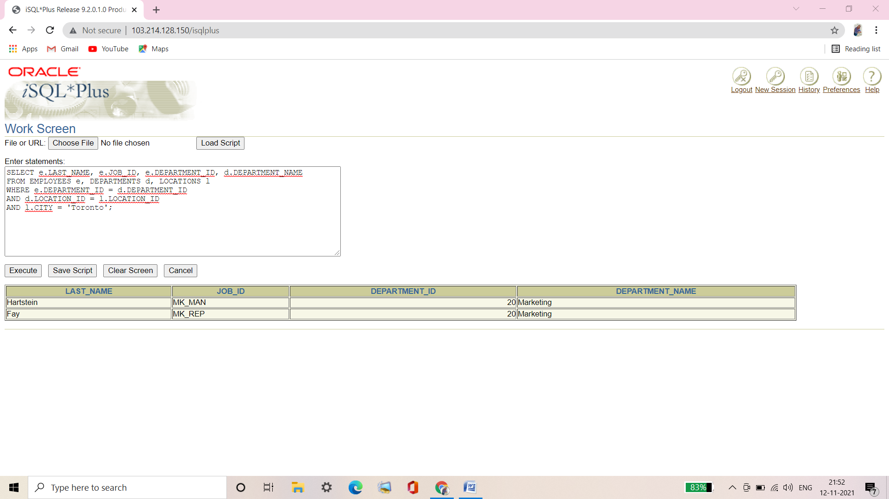

**Syntax of SQL: 1999 Compliant Joins:**

SELECT e.LAST_NAME, e.JOB_ID, e.DEPARTMENT_ID, d.DEPARTMENT_NAME

FROM EMPLOYEES e JOIN DEPARTMENTS d

ON (e.DEPARTMENT_ID = d.DEPARTMENT_ID)

JOIN LOCATIONS l

ON (d.LOCATION_ID = l.LOCATION_ID)

WHERE l.CITY = 'Toronto';

**Verification table-**

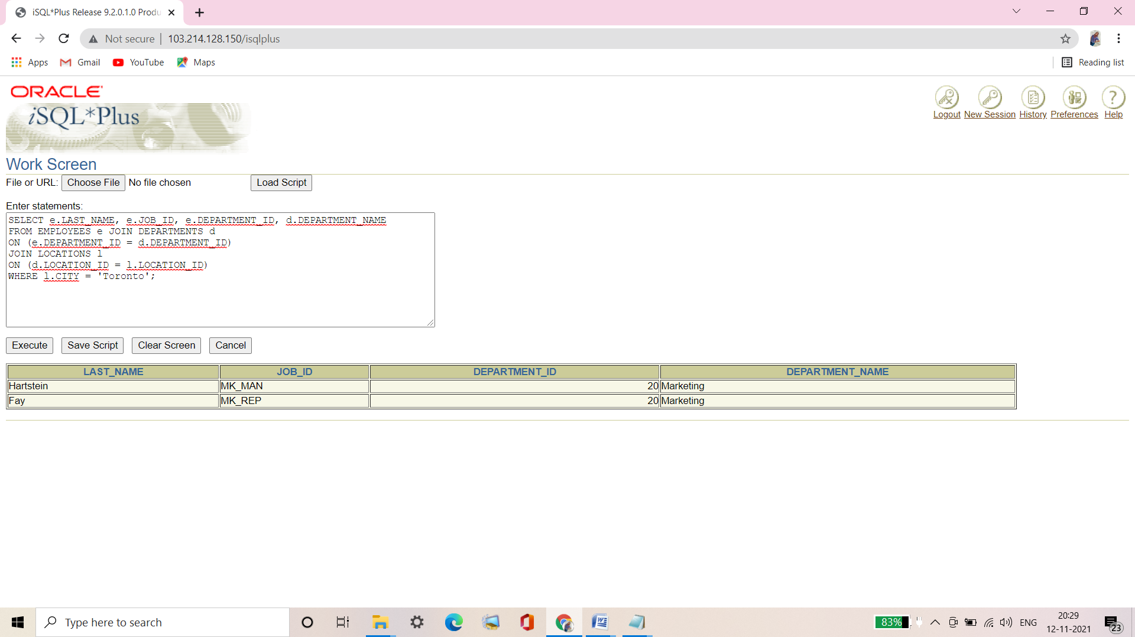

**Q6. Display the employee last name and employee number along with their manager’s last name and manager number. Label the columns Employee, Emp#, Manager, and Mgr#, respectively. Place your SQL statement in a text file named lab7_6.sql.**

|  |  |  |  |
| --- | --- | --- | --- |
| **Employee** | **Emp#** | **Manager** | **Mgr#** |
| **Kochhar** | **101** | **King** | **100** |
| **De Haan** | **102** | **King** | **100** |
| **Mourgos** | **124** | **King** | **100** |
| **Zlotkey** | **149** | **King** | **100** |
|  |  |  |  |
| **Abel** | **174** | **Zlotkey** | **149** |
| **Taylor** | **176** | **Zlotkey** | **149** |
| **Grant** | **178** | **Zlotkey** | **149** |
| **Fay** | **202** | **Hartstein** | **201** |
| **Gietz** | **206** | **Higgins** | **205** |

**19 rows selected.**

Ans6.

**Syntax of Oracle Proprietary Joins (8i and prior):**

SELECT e.LAST_NAME "Employee", e.EMPLOYEE_ID "Emp#",

m.LAST_NAME "Manager", m.EMPLOYEE_ID "Mgr#"

FROM EMPLOYEES e, EMPLOYEES m

WHERE e.MANAGER_ID = m.EMPLOYEE_ID;

**Verification table-**

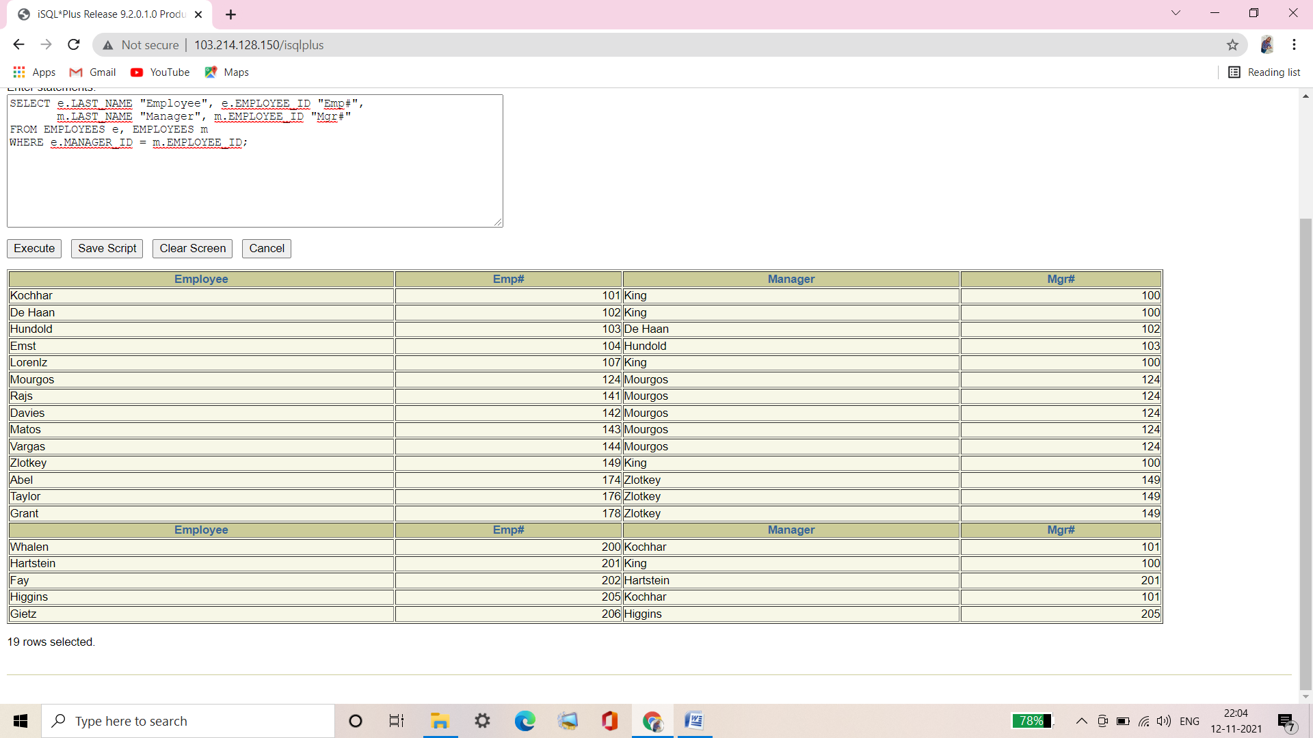

**Syntax of SQL: 1999 Compliant Joins:**

SELECT e.LAST_NAME "Employee", e.EMPLOYEE_ID "Emp#",

m.LAST_NAME "Manager", m.EMPLOYEE_ID "Mgr#"

FROM EMPLOYEES e JOIN EMPLOYEES m

ON (e.MANAGER_ID = m.EMPLOYEE_ID);

**Verification table-**

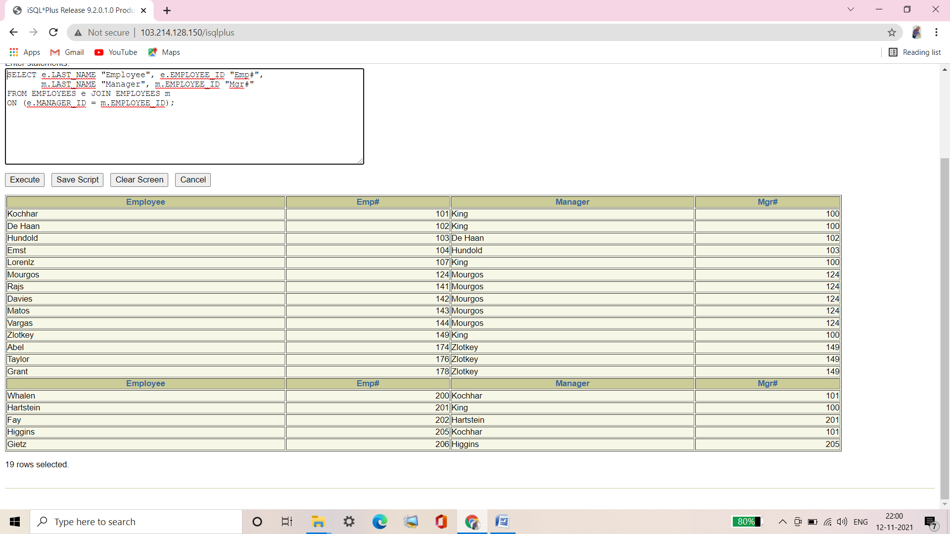

**Q7. Modify lab7_6.sql to display all employees including King, who has no manager. Order the results by the employee number.**

**Place your SQL statement in a text file named lab7_7.sql. Run the query in lab7_7.sql.**

|  |  |  |  |
| --- | --- | --- | --- |
| **Employee** | **Emp#** | **Manager** | **Mgr#** |
| **King** | **100** |  |  |
| **Kochhar** | **101** | **King** | **100** |
| **De Haan** | **102** | **King** | **100** |
| **Hunold** | **103** | **De Haan** | **102** |
| **Ernst** | **104** | **Hunold** | **103** |
| **Lorentz** | **107** | **Hunold** | **103** |
| **Mourgos** | **124** | **King** | **100** |
|  |  |  |  |
| **Higgins** | **205** | **Kochhar** | **101** |
| **Gietz** | **206** | **Higgins** | **206** |

**20 rows selected.**

Ans7.

**Syntax of Oracle Proprietary Joins (8i and prior):**

SELECT e.LAST_NAME "Employee", e.EMPLOYEE_ID "Emp#",

m.LAST_NAME "Manager", m.EMPLOYEE_ID "Mgr#"

FROM EMPLOYEES e, EMPLOYEES m

WHERE e.MANAGER_ID = m.EMPLOYEE_ID(+)

ORDER BY e.EMPLOYEE_ID;

**Verification table-**

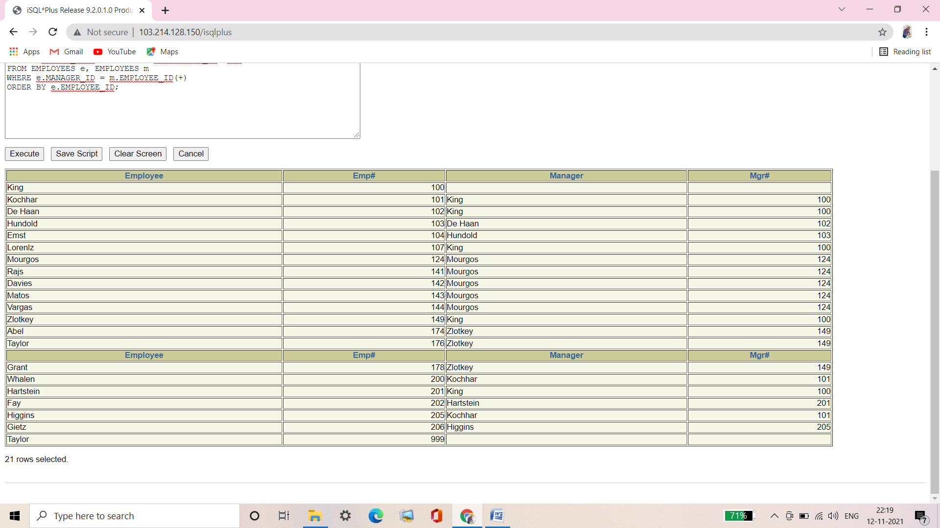

**Syntax of SQL: 1999 Compliant Joins:**

SELECT e.LAST_NAME "Employee", e.EMPLOYEE_ID "Emp#",

m.LAST_NAME "Manager", m.EMPLOYEE_ID "Mgr#"

FROM EMPLOYEES e

LEFT OUTER JOIN EMPLOYEES m

ON (e.MANAGER_ID = m.EMPLOYEE_ID)

ORDER BY e.EMPLOYEE_ID;

**Verification table-**

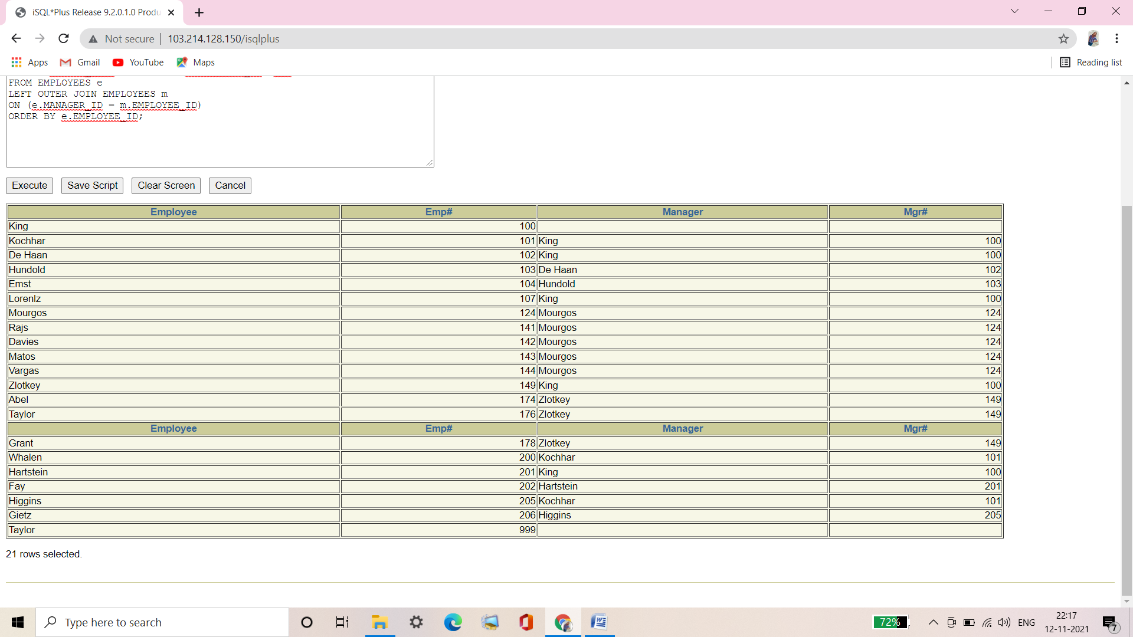

**Q8. Create a query that displays employee last names, department numbers, and all the employees who work in the same department as a given employee. Give each column an appropriate label.**

|  |  |  |
| --- | --- | --- |
| **DEPARTMENT** | **EMPLOYEE** | **COLLEAGUE** |
| **20** | **Fay** | **Hartstein** |
| **20** | **Harstein** | **Fay** |
| **50** | **Davies** | **Matos** |
| **50** | **Davies** | **Mourgos** |
| **50** | **Davies** | **Rajs** |
| **50** | **Davies** | **Vargas** |
| **50** | **Matos** | **Davies** |
| **50** | **Matos** | **Mourgos** |
| **50** | **Matos** | **Rajs** |
| **50** | **Matos** | **Vargas** |
|  |  |  |
| **110** | **Gietz** | **Higgins** |
| **110** | **Higgins** | **Gietz** |

**42 rows selected.**

Ans8.

**Syntax of Oracle Proprietary Joins (8i and prior):**

SELECT e.DEPARTMENT_ID DEPARTMENT, e.LAST_NAME EMPLOYEE,

c.LAST_NAME COLLEAGUE

FROM EMPLOYEES e, EMPLOYEES c

WHERE e.DEPARTMENT_ID = c.DEPARTMENT_ID

AND e.EMPLOYEE_ID <> c.EMPLOYEE_ID;

**Verification table-**

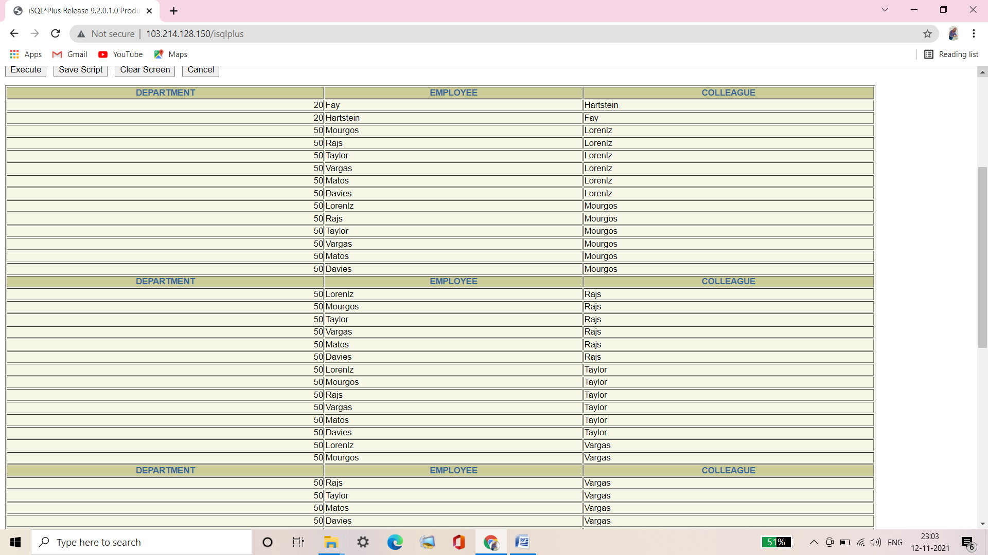

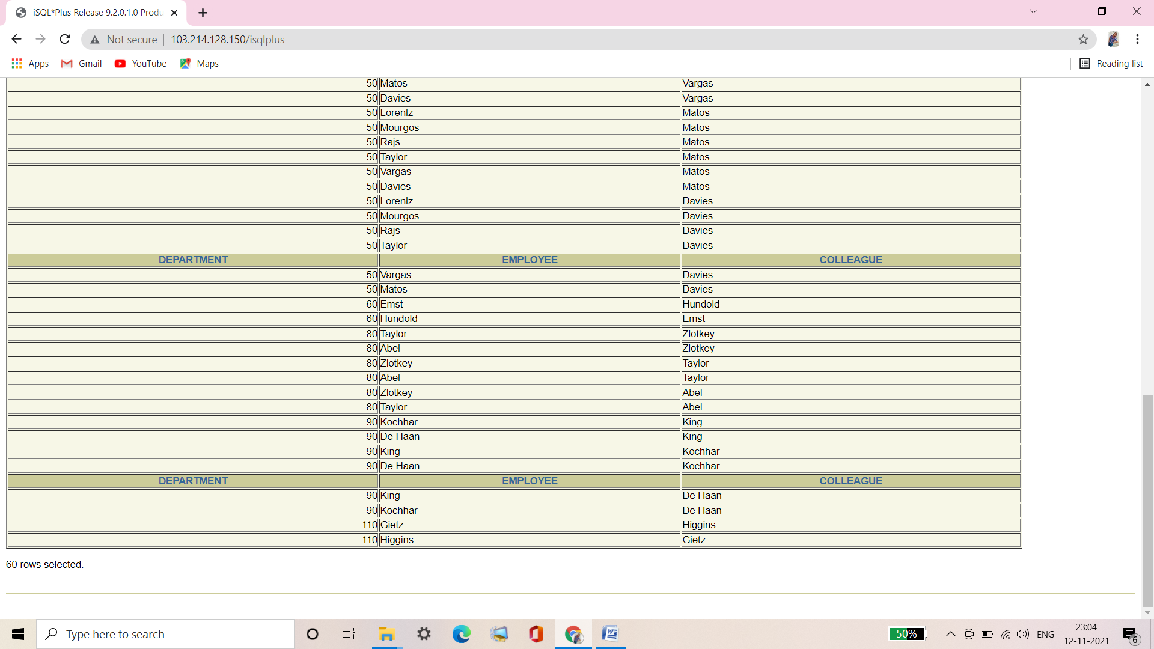

**Syntax of SQL: 1999 Compliant Joins:**

SELECT e.DEPARTMENT_ID DEPARTMENT, e.LAST_NAME EMPLOYEE,

c.LAST_NAME COLLEAGUE

FROM EMPLOYEES e JOIN EMPLOYEES c

ON (e.DEPARTMENT_ID = c.DEPARTMENT_ID)

WHERE e.EMPLOYEE_ID <> c.EMPLOYEE_ID;

**Verification table-**

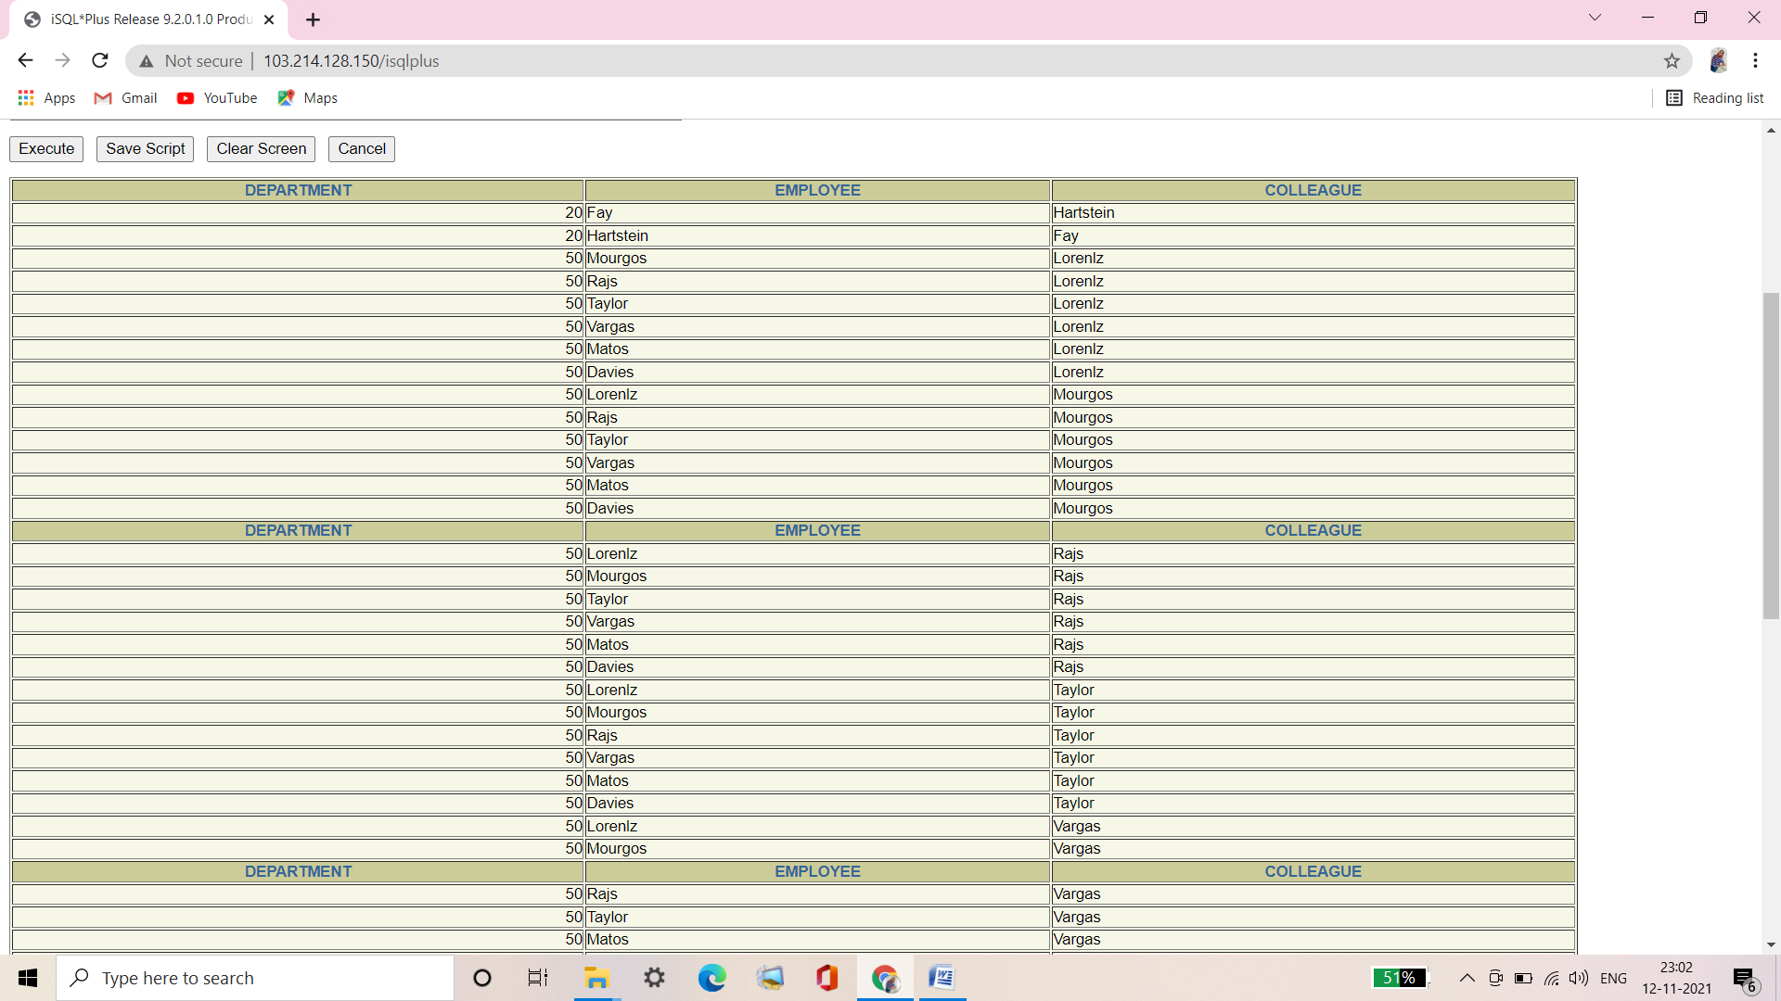

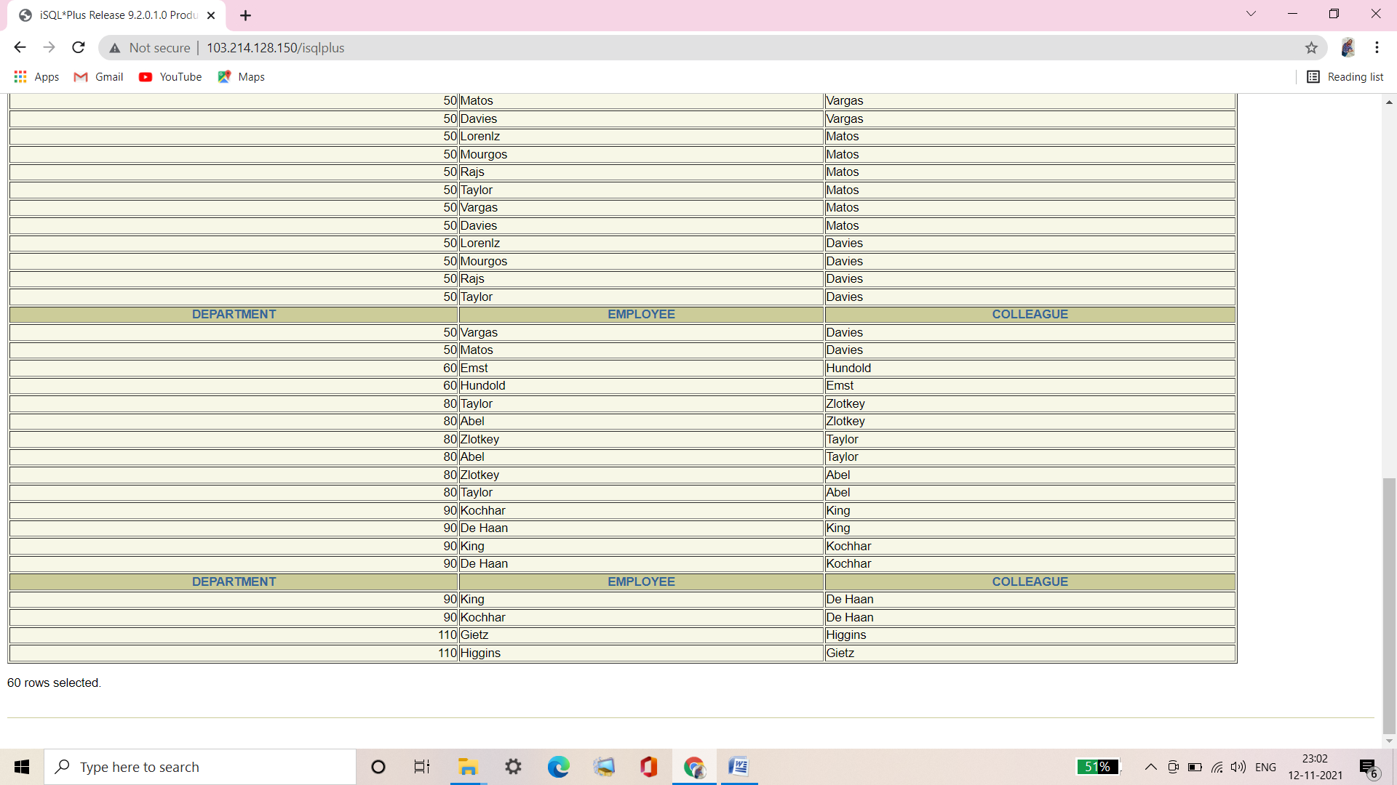

**Q9. Show the structure of the JOB_GRADES table. Create a query that displays the name, job, department name, salary, and grade for all employees.**

|  |  |  |
| --- | --- | --- |
| **Name** | **Null?** | **Type** |
| **GRADE_LEVEL** |  | **VARCHAR2(3)** |
| **LOWEST_SAL** |  | **NUMBER** |
| **HIGHEST_SAL** |  | **NUMBER** |

|  |  |  |  |  |
| --- | --- | --- | --- | --- |
| **LAST_NAME** | **JOB_ID** | **DEPARTMENT_NAME** | **SALARY** | **GRA** |
| **Matos** | **ST_CLERK** | **Shipping** | **2600** | **A** |
| **Vargas** | **ST_CLERK** | **Shipping** | **2500** | **A** |
| **Lorentz** | **IT_PROG** | **IT** | **4200** | **B** |
| **Mourgos** | **ST_MAN** | **Shipping** | **5800** | **B** |
| **Rajs** | **ST_CLERK** | **Shipping** | **3500** | **B** |
| **Davies** | **ST_CLERK** | **Shipping** | **3100** | **B** |
| **Whalen** | **AD_ASST** | **Administration** | **4400** | **B** |
|  |  |  |  |  |
| **De Haan** | **AD_VP** | **Executive** | **17000** | **E** |

**19 rows selected.**

Ans9.

**Syntax of Oracle Proprietary Joins (8i and prior):**

DESCRIBE JOB_GRADES;

SELECT e.LAST_NAME, e.JOB_ID, d.DEPARTMENT_NAME,

e.SALARY, j.GRADE_LEVEL

FROM EMPLOYEES e, DEPARTMENTS d, JOB_GRADES j

WHERE e.DEPARTMENT_ID = d.DEPARTMENT_ID

AND e.SALARY BETWEEN j.LOWEST_SAL AND j.HIGHEST_SAL;

**Verification table-**

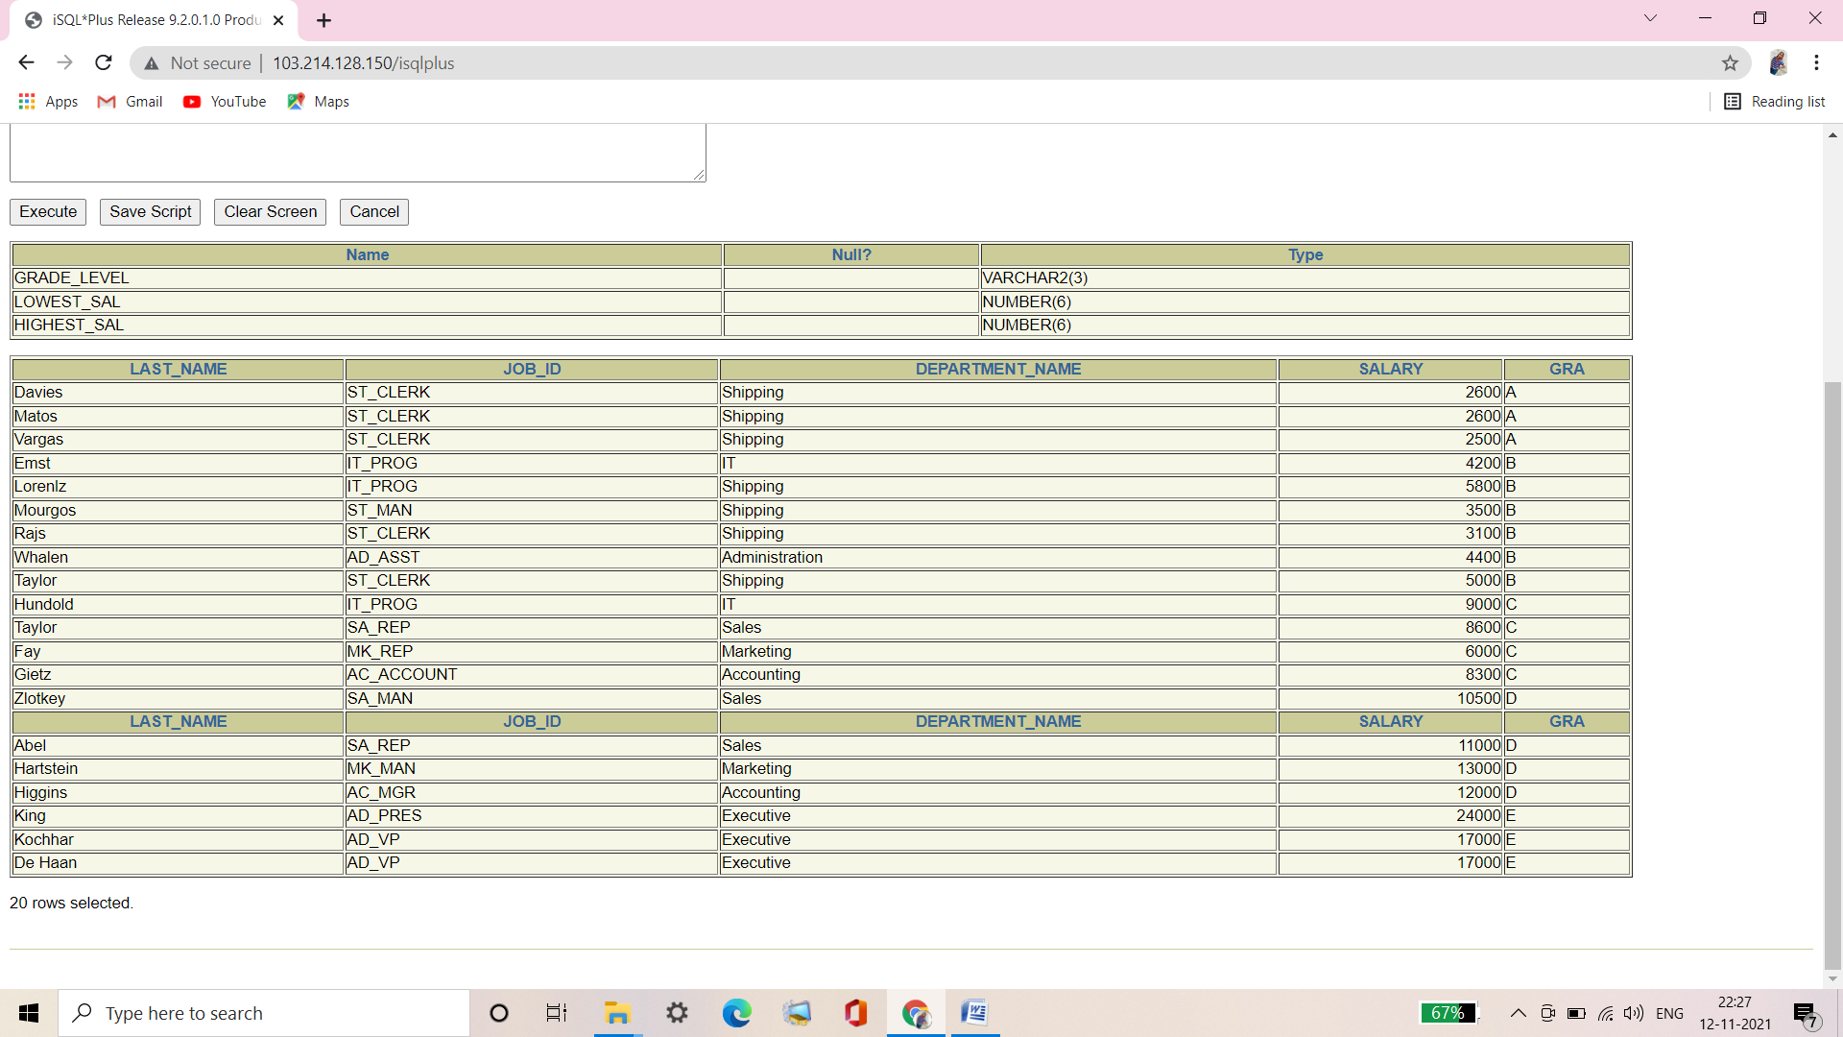

**Syntax of SQL: 1999 Compliant Joins:**

DESCRIBE JOB_GRADES;

SELECT e.LAST_NAME, e.JOB_ID, d.DEPARTMENT_NAME,

e.SALARY, j.GRADE_LEVEL

FROM EMPLOYEES E JOIN DEPARTMENTS d

ON (e.DEPARTMENT_ID = d.DEPARTMENT_ID)

JOIN JOB_GRADES j

ON (e.SALARY BETWEEN j.LOWEST_SAL AND j.HIGHEST_SAL);

**Verification table-**

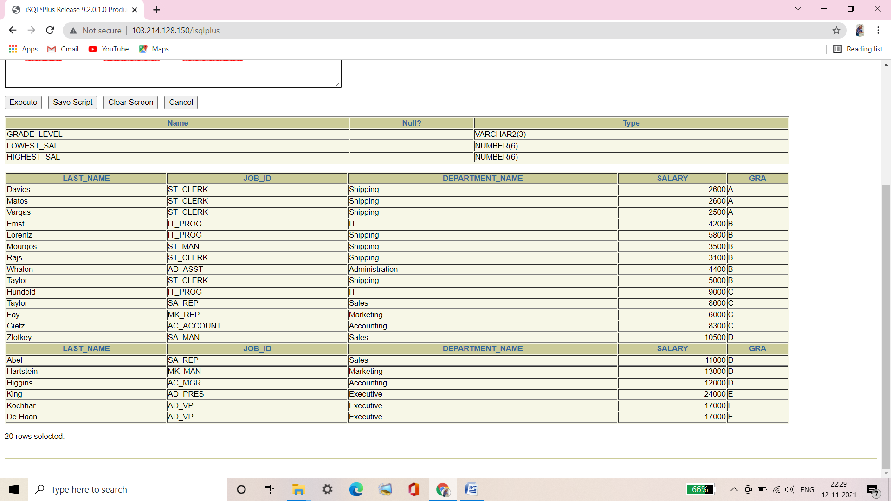

**Q10. Create a query to display the name and hire date of any employee hired after employee Davies.**

|  |  |
| --- | --- |
| **LAST_NAME** | **HIRE_DATE** |
| **Lorentz** | **07-FEB-99** |
| **Mourgos** | **16-NOV-99** |
| **Matos** | **15-MAR-98** |
| **Vargas** | **09-JUL-98** |
| **Zlotkey** | **29-JAN-00** |
| **Taylor** | **24-MAR-98** |
| **Grant** | **24-MAY-99** |
| **Fay** | **17-AUG-97** |

**8 rows selected.**

Ans10.

**Syntax of Oracle Proprietary Joins (8i and prior):**

SELECT e.LAST_NAME, e.HIRE_DATE

FROM EMPLOYEES e, EMPLOYEES d

WHERE d.LAST_NAME = 'Davies'

AND d.HIRE_DATE < e.HIRE_DATE;

**Verification table-**

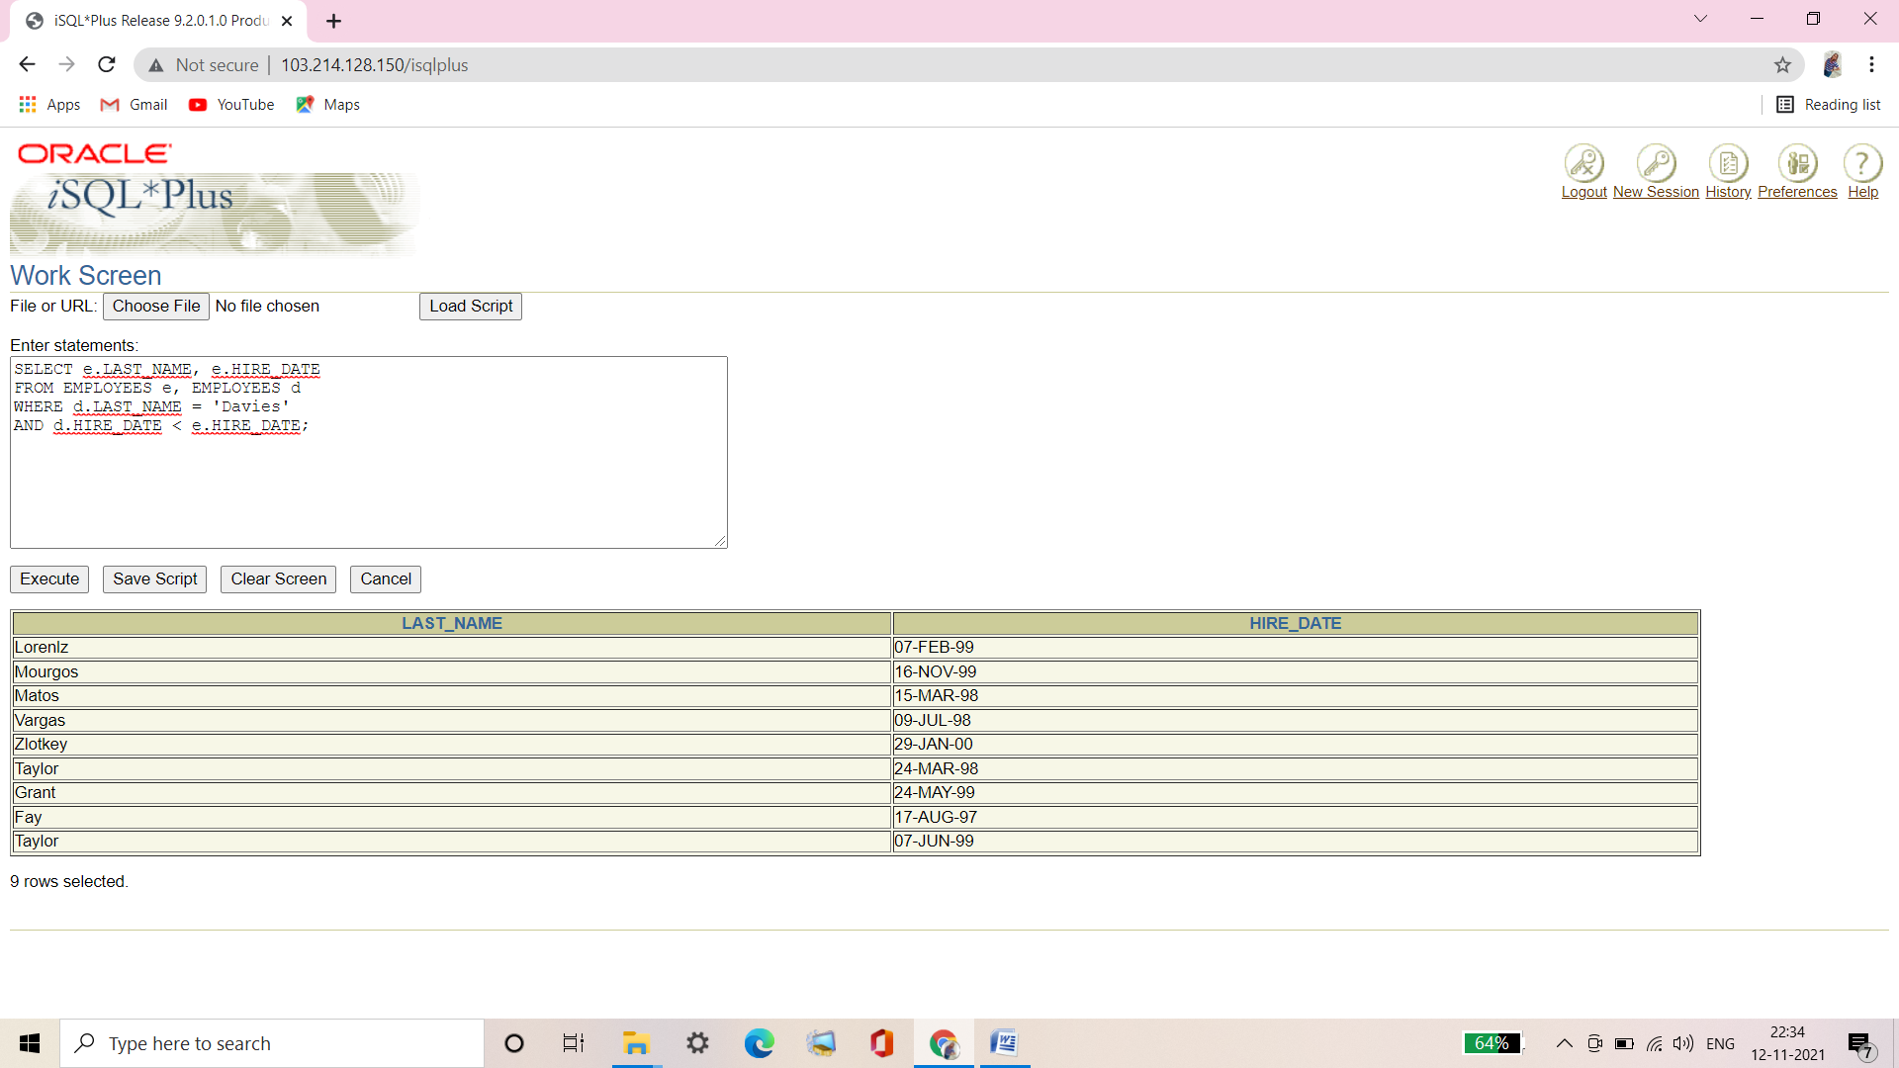

**Syntax of SQL: 1999 Compliant Joins:**

SELECT e.LAST_NAME, e.HIRE_DATE

FROM EMPLOYEES e JOIN EMPLOYEES d

ON (d.LAST_NAME = 'Davies')

WHERE d.HIRE_DATE < e.HIRE_DATE ;

**Verification table-**

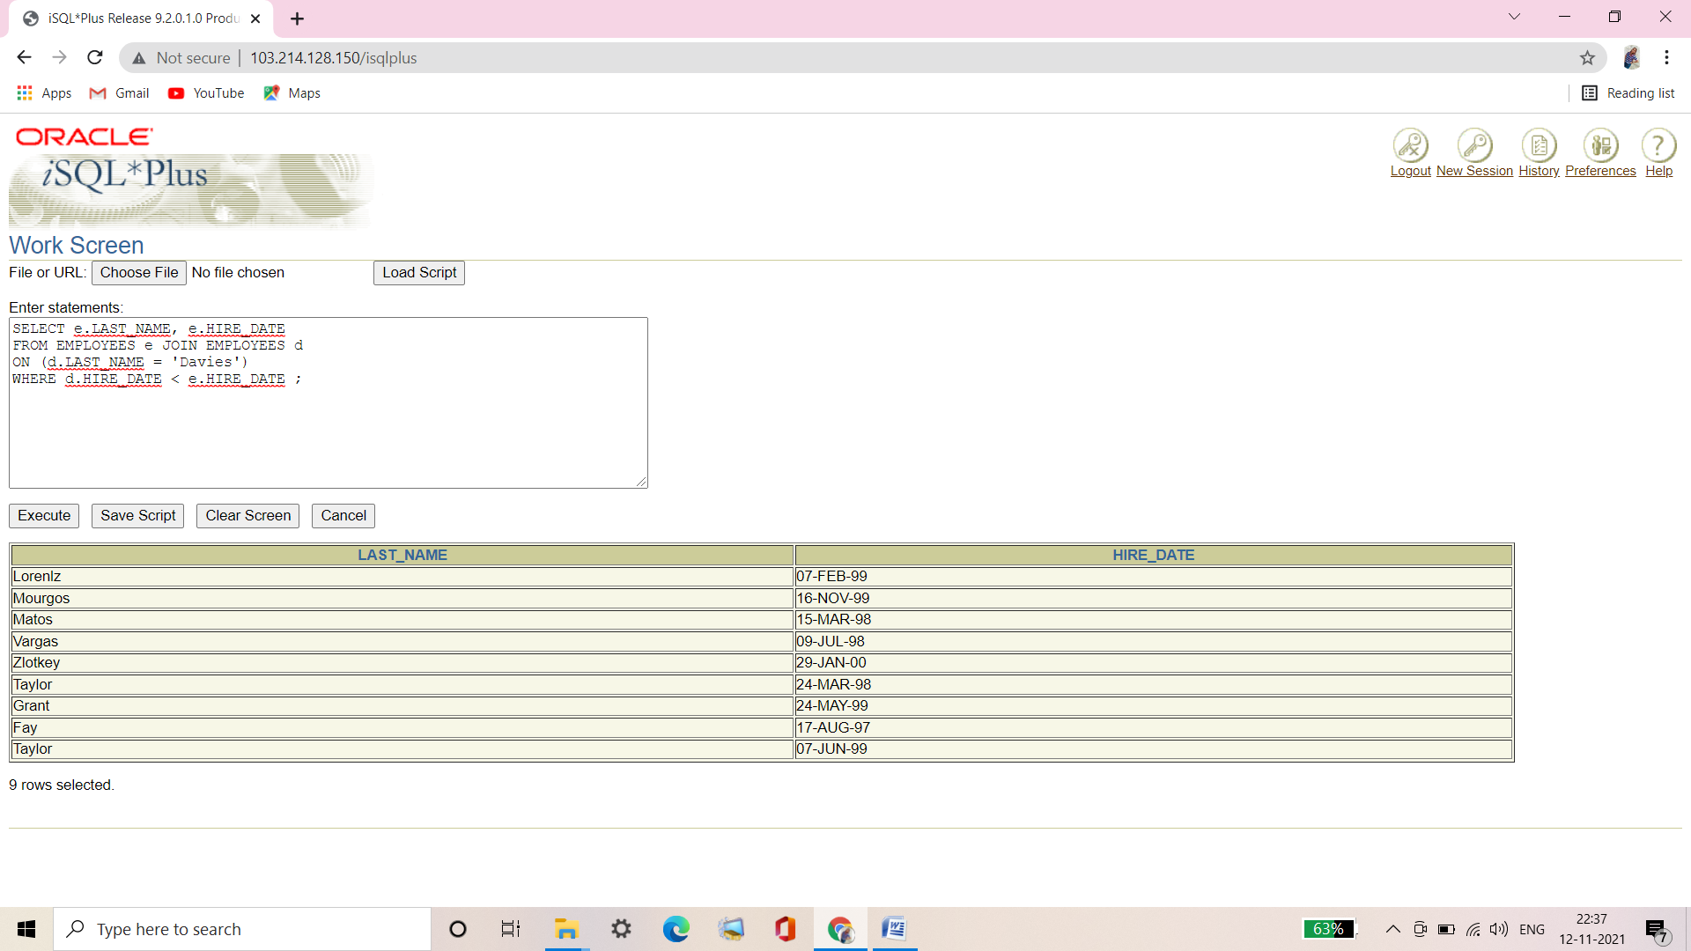

**Q11. Display the names and hire dates for all employees who were hired before their managers, along with their manager’s names and hire dates. Label the column Employee, Emp Hired, Manager, and Mgr Hired, respectively.**

|  |  |  |  |
| --- | --- | --- | --- |
| **Employee** | **Emp Hired** | **Manager** | **Mgr Hired** |
| **Whalen** | **17-SEP-87** | **Kochhar** | **21-SEP-89** |
| **Hunold** | **03-JAN-90** | **De Haan** | **13-JAN-93** |
| **Rajs** | **17-OCT-95** | **Mourgos** | **16-NOV-99** |
| **Davies** | **29-JAN-97** | **Mourgos** | **16-NOV-99** |
| **Matos** | **15-MAR-98** | **Mourgos** | **16-NOV-99** |
| **Vargas** | **09-JUL-98** | **Mourgos** | **16-NOV-99** |
| **Abel** | **11-MAY-96** | **Zlotkey** | **29-JAN-00** |
| **Taylor** | **24-MAR-98** | **Zlotkey** | **29-JAN-00** |
| **Grant** | **24-MAY-99** | **Zlotkey** | **29-JAN-00** |

**9 rows selected.**

Ans11.

**Syntax of Oracle Proprietary Joins (8i and prior):**

SELECT e.LAST_NAME "Employee", e.HIRE_DATE "Emp Hired",

m.LAST_NAME "Manager", m.HIRE_DATE "Mgr Hired"

FROM EMPLOYEES e, EMPLOYEES m

WHERE e.MANAGER_ID = m.EMPLOYEE_ID

AND e.HIRE_DATE < m.HIRE_DATE;

**Verification table-**

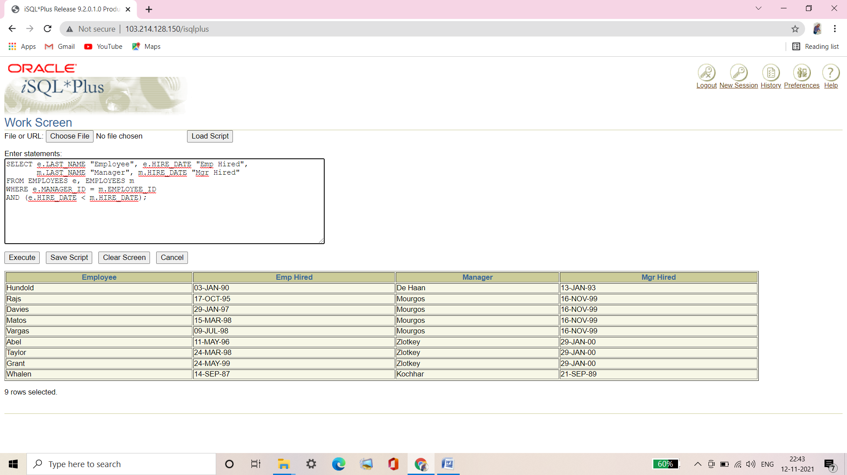

**Syntax of SQL: 1999 Compliant Joins:**

SELECT e.LAST_NAME "Employee", e.HIRE_DATE "Emp Hired",

m.LAST_NAME "Manager", m.HIRE_DATE "Mgr Hired"

FROM EMPLOYEES e JOIN EMPLOYEES m

ON (e.MANAGER_ID = m.EMPLOYEE_ID)

WHERE e.HIRE_DATE < m.HIRE_DATE;

**Verification table-**

